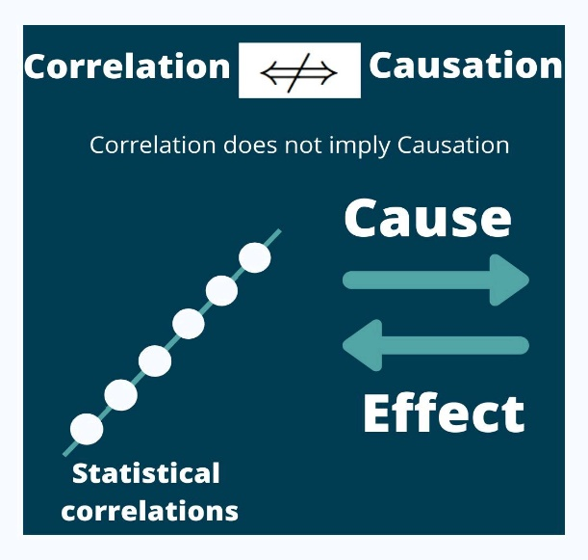

If we go straight by their definition, we can say that the two terms #correlation and #causation are different but there are many times that we often mixed up between the two.

Like many times we confuse in choosing our dependent and independent variables i.e., we assume X effects Y variable but sometimes its just opposite Y effects X variable. So statistics do not tell you anything about the direction relationship.

Sometimes we try to find out absurd reasons for our causality i.e., our X and Y are not related to each other. The solution obtained based on these #relations misleads us.

Many times there is a third #variable that affects our calculation i.e., there is a factor Z which affects our both the variables. Finding correct relations leads us to correct results.

There is an underlying variable that is mostly ignored while calculation i.e., Z---X---Y. This underlying Variable is s actually the cause of the changes in Y instead of your initial X variable.

Therefore while studying the data analytics part , I have understood one thing for sure that logical thinking helps a lot in interpreting the relationship between various data correctly. But these all depend on practice and experience to understand better in the analysis part.